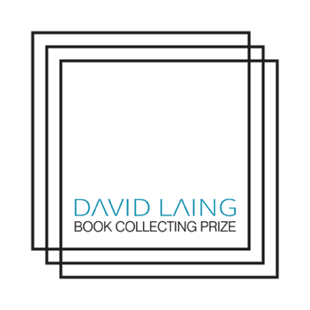

*November 2023*

**David Laing Student Book Collecting Prize   
Poster Design Competition 2023/24**

**Design a Poster Competition**The University of Edinburgh's Library is looking for a student to design an eye-catching   
poster to advertise The David Laing Student Book Collecting Prize.

Organised annually by The University of Edinburgh Centre for Research Collections,   
The David Laing Student Book Collecting Prize is offered in honour of David Laing (1793–1878),   
the distinguished antiquarian, collector and librarian who bequeathed his important collection   
of manuscripts and other materials to the University of Edinburgh in 1878.

**Open to:** all current ECA UG and PG Graphic Design and Illustration Students.

**Closing date:** 9am Monday 8 January 2024.   
The winner will be notified by 5pm on Friday 12 January 2024.

**Win:** The winner of the poster competition will win £250, and the chosen poster will be printed at various sizes (see below) and used across social media to publicise the David Laing Student Book Collecting Prize across the University to encourage entries to the Book Collecting Competition.

**Judges:** The competition will be judged by representatives from Heritage Collections,   
and Edinburgh College of Art and Nicky Regan, ECA Graphic Design Officer.

**Guidance:** The A3 design submission should be the original work of the student, and be sent as   
a high resolution PDF **file (no** bigger than 10MB) to the ECA Graphic Design Officer,   
Nicky Regan at:

[nregan@ed.ac.uk](mailto:nregan@ed.ac.uk)

**How to enter**

* Please title your email entry ‘David Laing Poster Competition’ and make sure   
  your PDF file name is of the format ‘yourfirstname_surname_poster.pdf’   
  (e.g. Brian_Smith_Poster.pdf)
* The winner may be expected to make minimal design changes required by   
  the judges before being printed and to reformat the design for use on social media.
* Only one entry per student.
* The designer will retain copyright to their work, but usage rights will be given to the University of Edinburgh as part of this submission process.

**Note:** Entering or winning the poster design competition **will not** preclude you from **also** entering   
the Book Collecting Competition.

**Information to include on your poster design**

**Title:** David Laing Book Collecting Prize / logo

**Closing date:** 9am Monday 25 March 2024.

**Prize:** The winner will receive £500 to spend on their own book collection

**Contact, and address for entries:** is-crc@ed.ac.uk

**Open to:** All current University of Edinburgh students.

**For:** A collection of books (loosely defined)

**Entry:** Submission of a short essay, list and pictures of the collection.

**Further information, rules and entry form link/this could be a QR code:**

[https://www.ed.ac.uk/information-services/library-museum-gallery/cultural-heritage-collections/crc/about/david-laing-prize](https://www.ed.ac.uk/information-services/library-museum-gallery/cultural-heritage-collections/crc/about/david-laing-prize" \o "https://www.ed.ac.uk/information-services/library-museum-gallery/cultural-heritage-collections/crc/about/david-laing-prize)

Poster designs must include the David Laing Book Collecting Prize logo, the University of Edinburgh logo and the Centre for Research Collections logo. These logos can be found online here along with an example of the previous poster design:

[DAVID LAING BOOK POSTER LOGOS](https://uoe-my.sharepoint.com/:f:/g/personal/nregan_ed_ac_uk/EpIiHA8scq1FllScD2SHW6MB3NEwfkUdr3Kz1Xsx8eecQg?e=EyPpbc)

Any queries should be addressed to:

Daryl Green,   
Head of Heritage Collections (Research & Curatorial)  
[Daryl.Green@ed.ac.uk](mailto:Daryl.Green@ed.ac.uk)

**Background of The David Laing Student Book Collecting Prize**

The Centre for Research Collections provides access to all the University’s heritage collections, including Archives, Rare Books, Art and Museum collections, and hosts Lothian Health Service Archives for the NHS. The University has been collecting since 1580, building up a wealth of material, including medieval manuscripts, printed books from the fifteenth century to the present, individual manuscripts and sets of personal papers recording the work of scholars and scientists, paintings and sculpture and museum objects. The collections are actively used for teaching and research, and continue to grow though purchase and donation.

The David Laing Prize is intended to encourage book collecting by undergraduates and   
graduate students of the University by recognising a collection formed by a student.

The winner of the David Laing Book Collecting Competition is decided based on the   
interest, originality, thoughtfulness and creativity of the book collection and vision,   
enthusiasm and persistence of the collector. The age, size and monetary value of the   
collection are not relevant criteria.

More information about the prize can be found here:

<https://www.ed.ac.uk/information-services/library-museum-gallery/cultural-heritage-collections/crc/about/david-laing-prize>

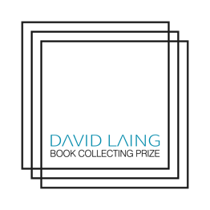  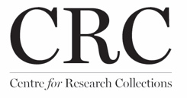

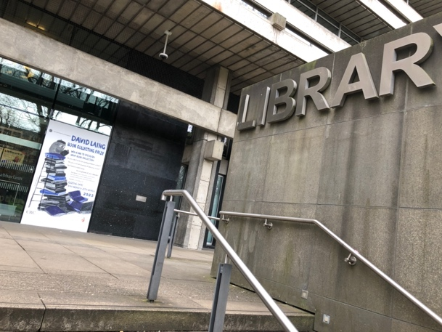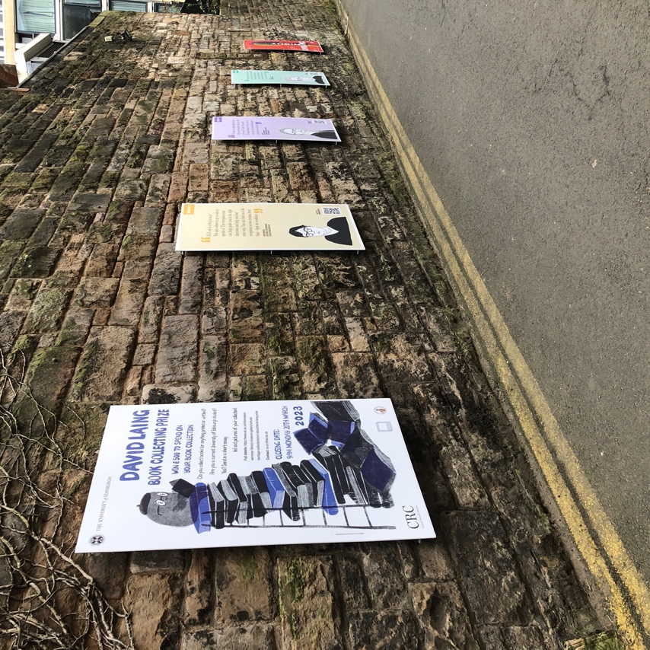

2023 winning design by Aner Wang, 3rd year Illustration.

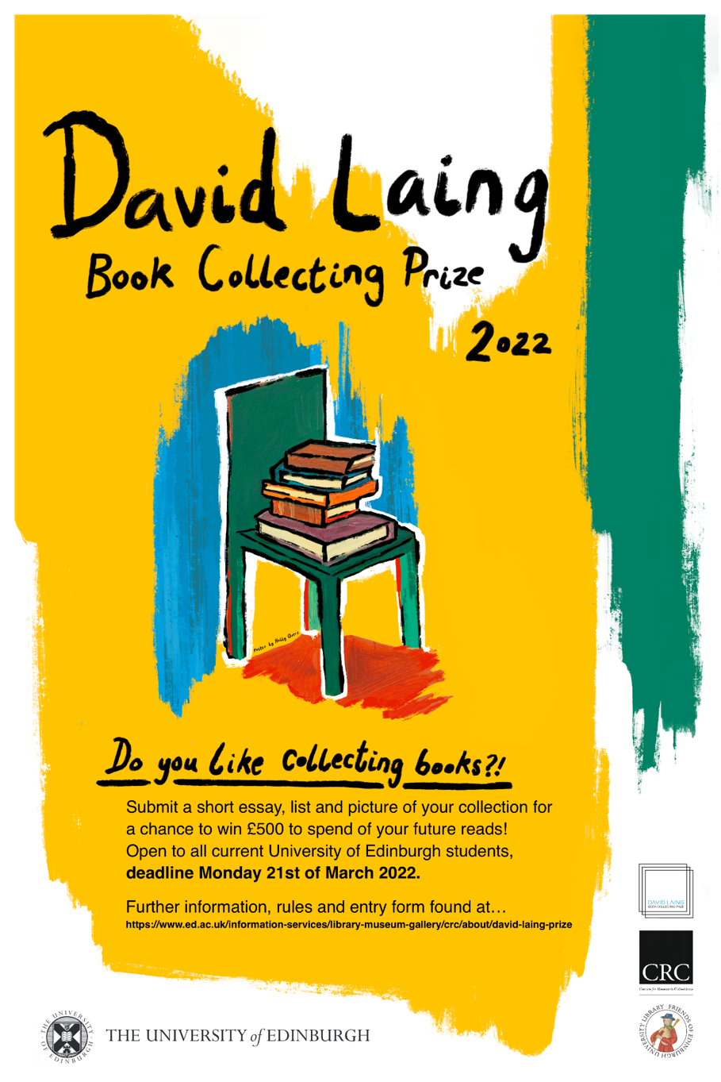

2022 winning design by Holly Overs, Illustration BA (Hons).