**LUNA Training**

**Public Web Browser**

Open a web browser and go to [www.images.is.ed.ac.uk](http://www.images.is.ed.ac.uk). This is the landing page for the image collections in LUNA. You do not need to login for these collections. It contains all the High Quality images that can be made publicly available. In general, images that are in copyright, under data protection or have been taken for behind the scenes management should not be available here. Furthermore, many legacy image collections from prior to 2004, are not available.

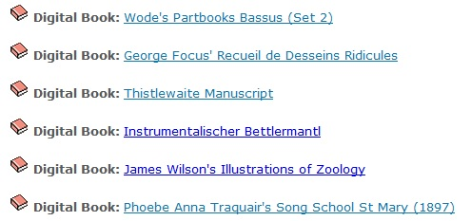

Click on the CRC Gallimaufry collection. On the front page you can see information about what the collection contains and copyright details for how the images can be used.

**Fig.1**

Below this, you can see that this collection contains some **Digital Books** (Fig.1).Click on Phoebe Anna Traquair. Click on the right-hand page to turn the pages of the book. In the top right corner of the image area, you can see there is a zoom tool. However, the images in the Digital Books are a very low resolution, so the quality will be poor when zoomed in.

**Fig.2**

To see full resolution images, click on

the link in the Description (Fig.2) in the Media Information panel on the left-hand side. If the thumbnail has the icon clicking on this thumbnail will take you back to the Digital Book. However, if you click on one of the other thumbnails you will be able to see the full-size image.

To **zoom** in (Fig.3) move your mouse over the lower 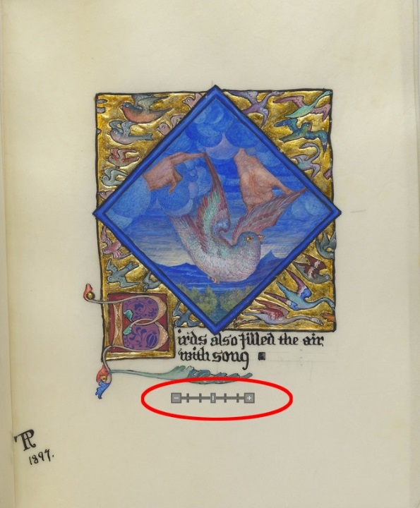part of the image and a zoom in/out scale should appear. As this is grey, it can sometimes get a bit lost in the image. You can also use the roller ball on your mouse. Left click, hold and drag to navigate around the image, or use the small navigation box (Fig.4) in the lower right corner to drag the zoom area around in the frame.

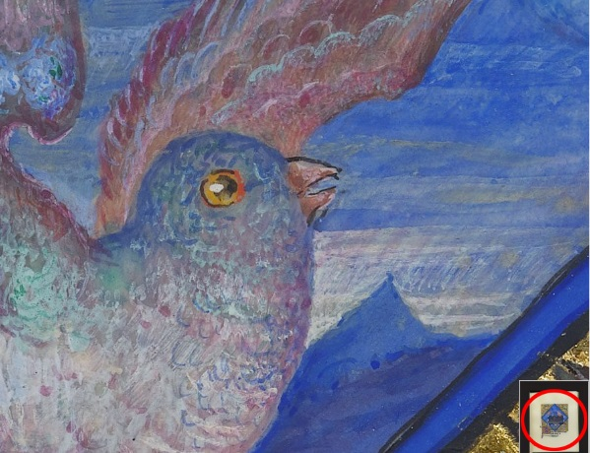In the left-hand media information panel you can see all the Metadata we have relating to this image. The first field is ‘**Work Record ID’** this is the number that we use to find the images on the server- use this number when requesting images for an order. The information we receive when image orders are placed ends up here, so accuracy is important.

**Fig.3**

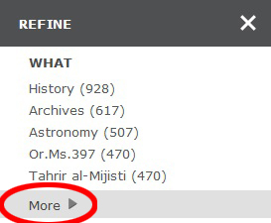Hover over ‘Collections’ and scroll down to select the Oriental Manuscripts Collection, then click on the ‘**Browse Oriental Manuscripts’** link above the thumbnails, this will take you into the all the images in this collection. To the right of the page above the thumbnails you can see how many images are in the collection and that it is displaying 50 per page. Click on the at the top right. This gives you some controls for increasing the number of images displaying per page and the size of the thumbnails, set this to suit yourself. You can also select **Sort** to adjust the order the thumbnails appear in.

**Fig.4**

**Fig.4**

Go to the ‘**Refine**’ panel on the left and click the ‘More’ toggle in the ‘What’ section (Fig.5), scroll down the page until you can see the shelfmark Or.Ms.20 (the (391) indicates how many images there are for this document) and click on this. Select any thumbnail.

**Fig.5**

If you want to share the link to this page click on **‘Share’** (Fig.6) in the menu bar, this will give you a shortened link you can paste into emails etc. However, this is not a permalink and will change over time.

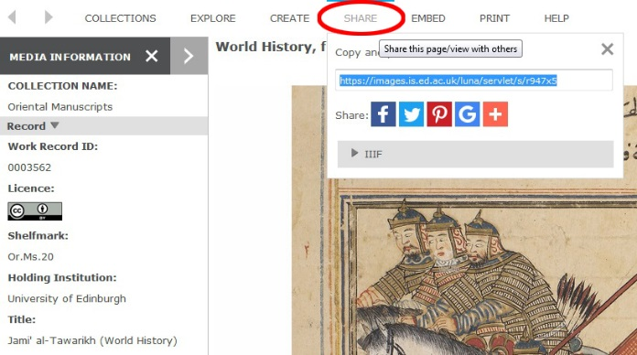If you want to download a copy of the image to use in presentations etc, click on the **‘Export’** button (Fig.7) at the top right-hand corner of the workspace (just to the left of the thumbnails).

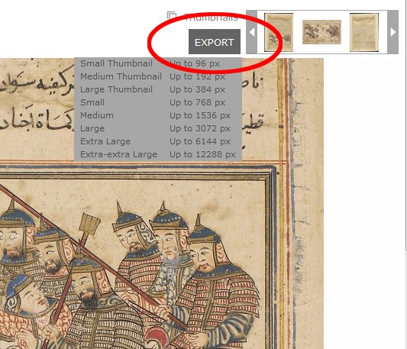Go to the menu bar and click on ‘Collections’ > ‘All Collections’. In the **Search** box on the right hand side type in the filename ‘0022378’. Click the search button. You can see the image is from the Incunabula collection and shelfmark CRC Inc.FF.13. Now go to ‘Collections’ > ‘Anatomy’ and type the same number filename ‘0022378’ in the search box. This time nothing is returned, this is because it will only search the images from the collection you are in. If you need to search across all collections you must make sure you are in ‘All Collections’.

**Fig.7**

**Fig.7**

**Fig.6**

**Fig.6**

**Fig.9**

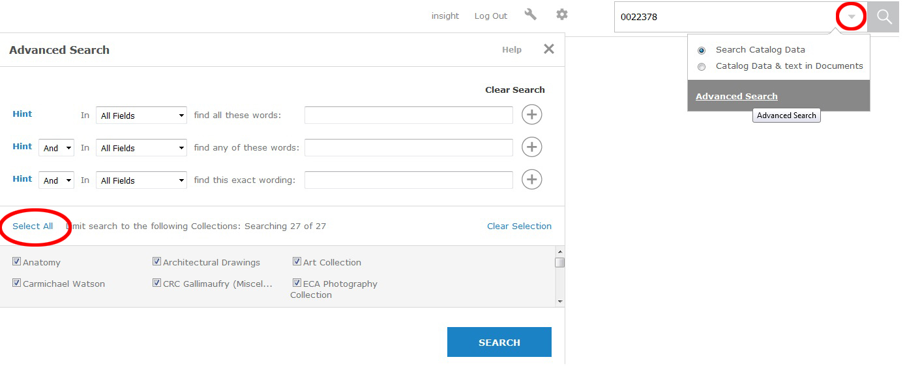Click on the drop-down arrow in the search box to access the ‘**Advanced Search**’ options (Fig.8). Click the ‘Select All’ button at the bottom of the box, so that you are searching across all collections. Then, fill in the relevant data for the image you wish to search for in the top boxes and search.

**Fig.8**

It is also possible to ‘**Browse Categories**’. Go to Collection>Hill and Adamson, then on the menu bar click ‘**Explore**’ and ‘**Browse Categories**’ You can see there are lists for ‘What’, ‘Where’ ‘Who’ and ‘When’. In the ‘Who’ list you can see there are 2 images for ‘Byrne, Patrick’, click on the link to take you to the images.

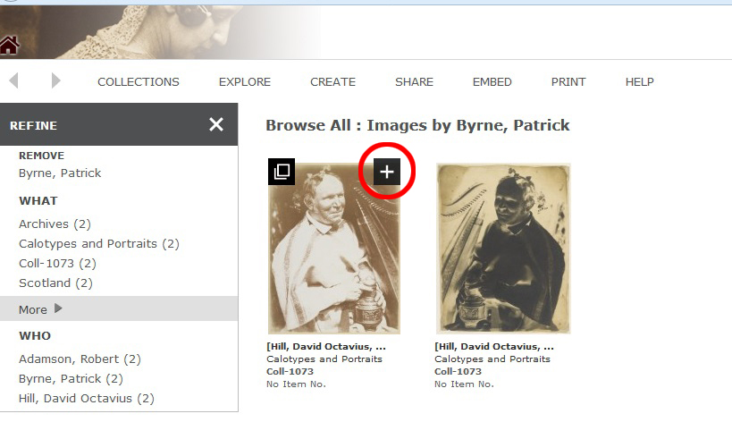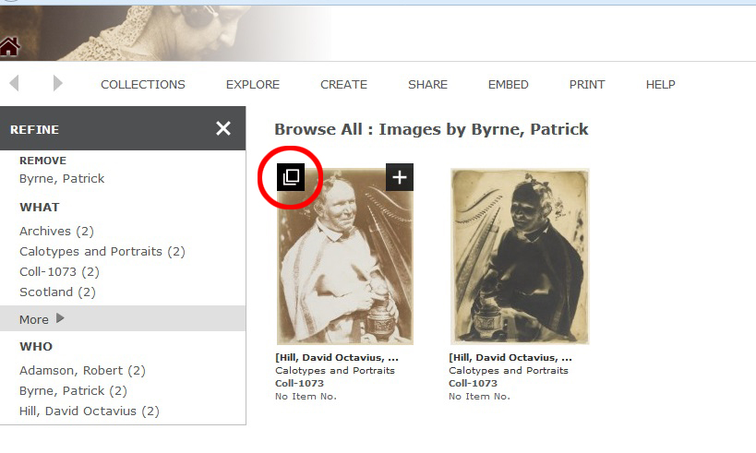Click on the first image. Hover over the thumbnail and Click the ‘**Add to Workspace’ icon** (Fig.9). This will open a workspace on another browser tab.

**Fig.9**

**Media Groups** are a useful way of grouping cross-collection content and making it accessible to anyone; they are often used for teaching. If you want to try this, go to Create>Media Groups. This will take you to a login page, if you haven’t already done so you will need to register, then login. Give your group a name, select “Publicly Viewable”, and select “Active Media Group”; other fields here are optional. Save.

**Fig.10**

**Fig.10**

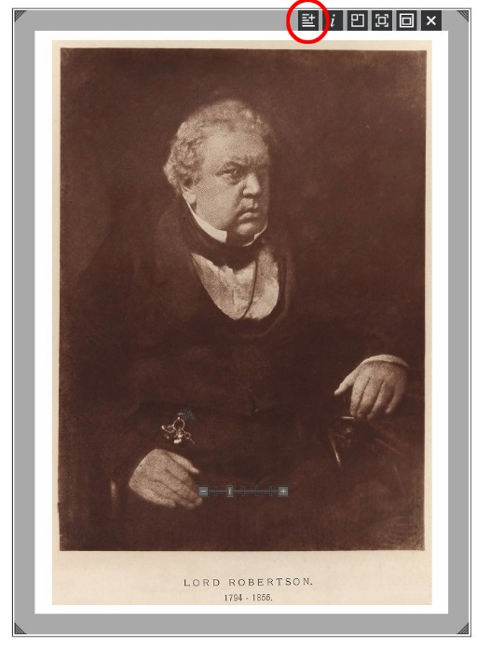Now, when you are browsing through the LUNA viewer, you will notice a ‘+’ icon in the top-left hand corner of each thumbnail (Fig.10). Clicking on this will add that image to this new Media Group, as that is active.

You can then view your Media Group by going to Explore>Media Groups. Select your group from the list. You will see there are a lot of functions available to you when you view your group, including viewing as a Slide Show, reordering, exporting the images to a zip file, or even to Powerpoint. Once you are in one of your Media Groups, you can open an image in the workspace and add an annotation to the image (Fig.11). Hover your mouse over the image and the tools will appear at the top right of the frame, the 1st from the left is the add annotation button.

**Fig.11**