Governance of the University of Edinburgh
A guide to the Centre for Research Collections’ sources for research

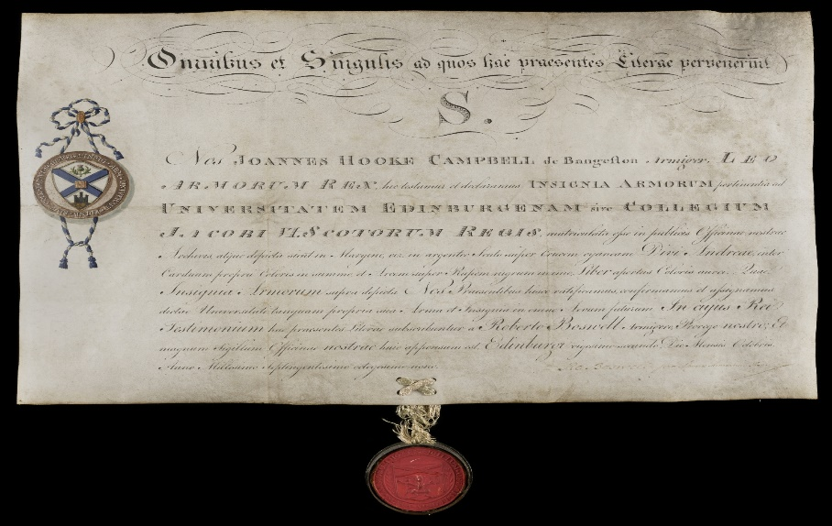
The University of Edinburgh’s matriculation of arms, 1789 (EUA CA10)

Introduction

The University of Edinburgh was founded by the Town Council of Edinburgh by royal charter in 1582 and opened to students in 1583. It continued to be governed by the Town Council until the Universities (Scotland) Act 1858 gave the University autonomy. Since 1858 it has had a tripartite constitution of three governing bodies: the University Court (its supreme governing body); the Senatus Academicus; and the General Council.

This guide summarises the University of Edinburgh’s history as it relates to governance, lists the Centre for Research Collection (CRC)’s main archival sources for researching the University’s governance, and outlines their access conditions.

Foundation of the ‘Tounis College’ by the Town Council of Edinburgh
In response to a petition from the Town Council of Edinburgh, King James VI of Scotland issued a royal charter on 14th April 1582 extending the remit of an earlier charter dispensed in 1567 by his mother, Mary Queen of Scots. Whereas Mary’s charter had granted the Town of Edinburgh the property formerly belonging to Edinburgh’s monastic orders in order to support the City’s clergy and poor, James’s charter empowered the Town Council to use this property for a college of higher education. It also granted the Town Council the right to appoint and dismiss college staff. This charter can be thought of as the University of Edinburgh’s founding charter, although strictly speaking it is a charter of confirmation and novodamus.

The Town Council were the founders of the University of Edinburgh and they continued to be its patrons and governors. Consequently, the University was initially known as the ‘Tounis College’. The Town Council had the power of appointing staff, approving curricula, and regulating finances. By custom the Lord Provost of Edinburgh was considered the ex officio Chancellor of the College, and from 1665 he also held the role of Rector (although in practice the Rectorship rapidly fell into disuse). The ‘College Council’ or ‘College Committee’ within the Town Council dealt with matters relating to the College. Initially the College’s finances were not separated out from the Town Council’s finances as a whole, but in 1640 a College Treasurer was appointed to keep separate accounts. As a result of the Town Council’s extensive involvement, the main primary source when researching governance of the University prior to 1858 is the Town Council minutes, which are held at Edinburgh City Archives.

The Senatus Academicus prior to 1858
As the 17th century progressed the College increasingly considered itself to be a ‘university’. The academic staff began to refer to themselves as a Faculty and, from the late 17th century, as the Senatus Academicus (or Senate). The Senate carried out much of the University’s routine administration and discipline. Their meetings were minuted by a Secretary – an office usually held by the University Librarian - and extant minutes survive from 1733 onwards. Because Senate was presided over by the Principal, its activity was dependent on individual Principals. There were no meetings of Senate 1753-1762 under elderly Principal John Gowdie, whereas under the active Principalship of the energetic William Robertson Senate took over most of the decisions regarding the degree structure and appointing Chairs (Professorships) between 1762 and 1778.

Power struggles between the Senate and the Town Council over their respective remits were common. One particularly hostile conflict resulted in the Town Council seizing the college records in 1704, ostensibly because the records were inaccurate, but really because the Town Council objected to the records’ use of the word ‘Faculty’ . In the 1820s, this hostility culminated in a legal battle between the Town Council and Senate which eventually led to the Town Council’s authority over the University being overthrown. In 1824 the Town Council ruled that midwifery should be made a compulsory component of the medical degree. Senate objected that curriculum was their remit, and began a series of legal suits which ended with the law courts finding in favour of the Town Council. However, Senate had meanwhile petitioned the crown to appoint a commission to settle the balance of powers between Senate and the Town Council. In 1826 a Royal Commission was called with the wider remit of framing a code of rules, statutes and ordinances for all Scottish universities. The Commission visited the universities to gather evidence about the rules and ordinances then in force and published reports which recommended constitutional reform. After a long delay, most of the measures recommended by the Commission passed into law with the Universities (Scotland) Act 1858.

The Universities (Scotland) Act 1858
The Universities (Scotland) Act 1858 gave the University of Edinburgh self-governing status. It removed control from the Town Council and passed it to three bodies: the Senatus Academicus, plus the newly-created University Court and General Council. Patronage of Chairs passed from the Town Council to the Curators of Patronage. The offices of Rector and Chancellor were revived or had their roles redefined. A series of later Acts – the most recent of which was passed in 2016 – altered some details, but the basic structure of governance today remains largely the same as in 1858.

The University Court and the Rector
The University Court was established by the 1858 Act and first met in 1859. Initially its function was to review the Senate’s decisions, to sanction expenditure of University funds by the Senate, and to undertake general supervision of the professors. Following the passage of the Universities (Scotland) Act 1889 it became the University’s supreme governing body, responsible for finances and administration and with powers to appoint and dismiss academic staff. The original membership comprised the Rector, Principal, Lord Provost of Edinburgh, and five Assessors (appointed by the Chancellor, Town Council, Rector, General Council and Senate). Currently (as of 2025), membership includes the Rector; Principal; Senior Lay Member; seven Assessors; six members elected or nominated by staff, University trade unions and the Students’ Association; and seven to nine co-opted members appointed following an open recruitment process. The Court has at least five ordinary meetings each academic year and may call special meetings.

The University Court is chaired by the Rector, a role revived in 1858 after falling into disuse (the role had been largely ceremonial throughout University’s history except for the brief period 1640-1651, when the Rector acted as an intermediary between the Town Council and the College). The Rector is elected for a three-year term and is the third ranking official in the University after the Chancellor and the Vice-Chancellor. Whereas in other Scottish universities the students alone elect the Rector, in Edinburgh the electorate was extended to staff in 1977. The Rector cannot be a current member of University staff or (since 1977) a current student. They have typically been politicians, political activists, or well-known public figures. Over time the Rector’s role has evolved into being a representative of student concerns and an ambassador for the University to the public.

The modern Senate, the General Council and the Curators of Patronage
Since the Universities (Scotland) Act 1889 made the University Court the University’s senior governing body, the Senate has focused solely on academic matters, regulating and superintending teaching and discipline of the University. It also elects Assessors to the University Court. As of 2025, University of Edinburgh Senate membership is composed of 100 elected professorial members, 100 elected non-professorial academic staff members, 30 elected student members, and up to 80 ex-officio members. It continues to be presided over by the Principal. Senate holds at least four in-person ordinary meetings and four online ‘E-senates’ a year plus graduation meetings, and can hold special meetings.

The General Council is the third body within the University’s tripartite constitution, alongside the University Court and the Senate. It was introduced by the Universities (Scotland) Act 1858 and is designed to involve graduates in the governance of their university. All University of Edinburgh graduates are members of the General Council in conjunction with the Chancellor, members of the University Court, and University of Edinburgh academic staff. The General Council elects the Chancellor. It has the right to consider all issues relating to well-being and prosperity of the University and to make representations on these issues to the University Court. Since 1966 General Council also has the power to consider draft Ordinances and Resolutions, to be presented with an annual report of the work and activities of the University by the Principal, and to receive an audited financial statement. It has the responsibility of maintaining a register of all University of Edinburgh graduates. General Council meets twice a year, and its Business Committee deals with any matters arising in the interim.

General Council meetings are chaired by the Chancellor (or the Rector in the Chancellor’s absence). The role of Chancellor is largely ceremonial; the main duty - conferring degrees – can be carried out by the Vice-Chancellor on the Chancellor’s behalf. By custom the Principal is the Vice-Chancellor and confers degrees. Prior to 1858 the Lord Provost of Edinburgh was ex officio Chancellor of the University; since the 1858 Act the Chancellor has been elected by the General Council. The position of Chancellor was held for life up until Prince Philip retired in favour of his daughter Anne, the Princess Royal, in 2010.

With the passing of the 1858 Act, the Curators of Patronage assumed responsibility for the patronage of Chairs. There are seven Curators: initially four were elected by the Town Council and three by the University Court, but since 1966 the Town Council has elected three and the University Court four. The Curators have the right of nomination to the office of Principal. They have the patronage of sixteen Chairs and a share in the patronage of six others. However, the majority of the University’s Chairs are appointed by the University Court, and the Curators’ powers are largely formal.

Administration: the Uni Secretary, committees and faculties
The Senate and the University Court had separate secretaries until 1918, when the new position of University Secretary was established. The University Secretary carries out duties for both the University Court and the Senate, and oversees the general secretarial business of the University.

Some University decision making is carried out at a lower level by Colleges (or, pre-2002, by Faculties), and by various committees. Governance issues may pass back and forth between different levels. It is therefore often worth checking the relevant College/Faculty and committee records in addition to those of the University Court, Senate and General Council.

Collections relating to University governance in the CRC archives

- Extracts from the City records concerning the University of Edinburgh, 1563-1779. Dc.5.5
- University of Edinburgh charter, 1582 EUA GD4
- Documents relating to the University of Edinburgh from the City records, 17th-century. Mic.M.3
- Papers illustrative of the history and constitution of the University of Edinburgh, 1611-1742. Dc.1.4
- University of Edinburgh matriculation of arms, 1789 EUA CA10
- Senatus Academicus records, 1733-2002 EUA IN1/GOV/SEN
- Returns by the University of Edinburgh in answer to the requisition made by the Royal Commission appointed for the visitation of the Universities and Colleges of Scotland, 1826-1828. Dc.1.78
- University Commissioners’ reports, 1832-1910 EUA IN1/GOV/CRT/COM
- University Court records (includes pre-1858 documents relating to the legal basis of the University), 1644- EUA IN1/GOV/CRT
- Rector records, 1865-2003 EUA IN1/GOV/Da.12
- Records of Edinburgh University Rectorial Association, 1887 EUA GD1
- General Council records, 1859- EUA IN1/GOV/GEC
- Chancellor records, 1930-1983 EUA IN1/GOV/Da.11
- Students’ Representative Council, 1884-1956 EUA IN20/SRC
- Records of the Curators of Patronage, 1820-1961 EUA IN1/GOV/PAT
- University Secretary records, 1833- EUA IN1/ADS/SEC
- Senior committees records, 1582- EUA IN1/COM
- Faculty of Arts records, 1777-2002 EUA IN1/ACA/ART
- Faculty of Law records, 1863-1919 EUA IN1/ACA/LAW
- Faculty of Medicine records, 1776-1987 EUA IN1/ACA/MED
- Faculty of Music records, 1838-1985 EUA IN1/ACA/MUS
- Faculty of Science and Engineering records, 1865-1996 EUA IN1/ACA/SCI
- Faculty of Veterinary Medicine records, 1951-2002 EUA IN1/ACA/VET
- Edinburgh University Calendar, 1858-2003 EUA IN1/PUB/1 and EUA.P.1

Related material elsewhere

- Edinburgh Town Council minutes, 1456-1975 Edinburgh City Archives, SL1/1

Accessing the collections

Digitised records and online indexes
The University’s 1582 charter and its matriculation of arms have been digitised and can be viewed on our Image Collections website.

An index to the Senate minutes for 1733-1855 is available online.

Some records of recent production from the University’s governing bodies are available digitally. These include agendas, papers and minutes for the University Court from 2009/10 onwards and the Senate from 2015/16, plus the most recent edition of the General Council billet and annex.

Selected editions of the Edinburgh University Calendar have been digitised for the time period 1858-1920.

Accessing physical records in person
Most records relating to the governance of the University have not been digitised, and only exist as physical items held in the archives. They can be consulted in person in the CRC Reading Room. To book an appointment, please email heritagecollections@ed.ac.uk or phone 0131 650 8379.

For those unable to visit in person we also offer ‘virtual’ online appointments, digitisation, and a remote enquiries service. See https://library.ed.ac.uk/heritage-collections/using-the-collections for more information

The University’s historian Alexander Grant argues that it is probable that this charter was subsidiary to a true founding charter also granted on the same day by James VI, which was has since been lost (Alexander Grant, ‘The story of the University of Edinburgh during its first 300 years’, London, Longmans, Green &Co., 1884, vol.i pp.109-121)
These college records, containing minutes of Faculty/Senate meetings from 1645-1703, were deposited in the Town Council’s charter house. They were produced during the 1825-1829 legal battle between the Town Council and the Senate, but have since been lost.
The Rectorship was held by two postgraduate students in the 1970s: Jonathan Wills (1971-2) and future UK prime minister Gordon Brown (1972-6)
A similar consideration was reflected in the formal recognition of the Students’ Representative Council (SRC) by the Universities (Scotland) Act 1889. The President and Vice-President of the SRC represent the student body at the University Court, and the SRC organises Welcome Week

